**KELOMPOK 1**

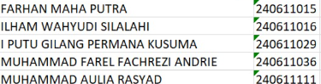

**1. Menu Aktif (Highlight Menu Saat Diklik)**

**Tujuan:**  
Agar menu yang sedang dibuka/aktif akan tertandai (misal warna gelap).

**Langkah:**

* Pada file layout menu (misal: layout/admin/layout.php), tambahkan logika untuk menandai menu aktif berdasarkan URL.

<!DOCTYPE html>

<html lang="en">

<head>

    <meta charset="utf-8" />

  <meta name="viewport" content="width=device-width, initial-scale=1, shrink-to-fit=no">

  <link rel="apple-touch-icon" sizes="76x76" href="../assets/img/apple-icon.png">

  <link rel="icon" type="image/png" href="../assets/img/favicon.png">

  <title>

    Tugas Besar Web

  </title>

  <link rel="stylesheet" href="<?= base_url('css/bootstrap.min.css') ?>" />

  <link href="https://cdn.jsdelivr.net/npm/bootstrap@5.0.2/dist/css/bootstrap.min.css" rel="stylesheet" integrity="sha384-EVSTQN3/azprG1Anm3QDgpJLIm9Nao0Yz1ztcQTwFspd3yD65VohhpuuCOmLASjC" crossorigin="anonymous">

  <link rel="stylesheet" href="<?= base_url('css/nucleo-icons.css') ?>" />

  <link rel="stylesheet" href="<?= base_url('css/nucleo-svg.css') ?>" />

  <link rel="stylesheet" href="<?= base_url('css/argon-dashboard.css?v=2.0.4') ?>" />

  <link rel="stylesheet" href="<?= base_url('fonts/https://fonts.googleapis.com/css?family=Open+Sans:300,400,600,700') ?>" />

  <link rel="stylesheet" href="https://cdnjs.cloudflare.com/ajax/libs/font-awesome/6.4.0/css/all.min.css" />

</head>

<body style="background: linear-gradient(90deg,#5e72e4 0,#825ee4 100%); min-height:100vh;">

    <?= $this->include('layout/admin/navbar') ?>

    <div style="min-height:100vh; margin-left:220px; padding:32px 32px 0 32px; background: transparent;">

      <?= $this->renderSection('content') ?>

    </div>

    <!-- js-->

    <script src="<?= base_url('js/jquery.min.js') ?>"></script>

    <script src="<?= base_url('js/bootstrap.min.js') ?>"></script>

    <script src="<?= base_url('js/core/popper.min.js') ?>"></script>

  <script src="<?= base_url('js/core/bootstrap.min.js') ?>></script>

  <script src="<?= base_url('js/plugins/perfect-scrollbar.min.js') ?>></script>

  <script src="<?= base_url('js/plugins/smooth-scrollbar.min.js') ?>"></script>

  <script>

    var win = navigator.platform.indexOf('Win') > -1;

    if (win && document.querySelector('#sidenav-scrollbar')) {

      var options = {

        damping: '0.5'

      }

      Scrollbar.init(document.querySelector('#sidenav-scrollbar'), options);

    }

  </script>

  <!-- Github buttons -->

  <script async defer src="https://buttons.github.io/buttons.js"></script>

  <!-- Control Center for Soft Dashboard: parallax effects, scripts for the example pages etc -->

  <script src="../assets/js/argon-dashboard.min.js?v=2.0.4"></script>

  <script src="https://cdn.jsdelivr.net/npm/bootstrap@5.0.2/dist/js/bootstrap.bundle.min.js" integrity="sha384-MrcW6ZMFYlzcLA8Nl+NtUVF0sA7MsXsP1UyJoMp4YLEuNSfAP+JcXn/tWtIaxVXM" crossorigin="anonymous"></script>

</body>

</html>

**2. Fitur Manajemen User per Role**

1. **Menambah Kolom Role (Jika Belum Ada), Masuk ke cmd ketik :**

**MYSQL -U ROOT -P**

**USE tubes-web;**

**ALTER TABLE users ADD COLUMN role VARCHAR(20) NOT NULL DEFAULT 'staff';**

1. **Insert user** 
   * **Admin**

INSERT INTO users (username, password, role) VALUES ('admin', '$2y$10$hashadmin', 'admin');

* + **Manajer**

INSERT INTO users (username, password, role) VALUES ('manajer', '$2y$10$hashmanajer', 'manajer');

**Buat hash.php dan ini dengan :**

<?php

echo password_hash('admin', PASSWORD_BCRYPT) . PHP_EOL;

echo password_hash('manajer123', PASSWORD_BCRYPT) . PHP_EOL;

?>

**Jalankan dengan cara : php .\hash.php lalu copy hash code ke kolom password di mysql**

**a. Struktur Role & Hak Akses**

* **Admin:** CRUD user (tambah, ubah, hapus), kelola role staff & manajer, CRUD data tabel, export excel.
* **Manajer:** CRUD data pada tiap tabel, tidak bisa kelola user, export excel.
* **Staff:** Hanya bisa melihat data dan export Excel, tidak bisa CRUD

**B. Hak akses di controller**

Contoh :

<?php

// app/Controllers/UserManagement.php

public function index() {

    $session = session();

    if ($session->get('role') !== 'admin') {

        return redirect()->to('/dashboard');

    }

    // ...load user data

}

// app/Controllers/Table1a1.php (dan tabel lain)

public function create() {

    $role = session()->get('role');

    if ($role !== 'admin' && $role !== 'manajer') {

        return redirect()->to('/table/table1a1');

    }

    // ...proses tambah data

}

public function delete($id) {

    $role = session()->get('role');

    if ($role !== 'admin' && $role !== 'manajer') {

        return redirect()->to('/table/table1a1');

    }

}

**c. Form Tambah/Ubah User (Admin Saja)**

**Contoh:**

<?php

<!-- app/Views/user_management.php -->

<?php if (session()->get('role') === 'admin'): ?>

<button data-bs-toggle="modal" data-bs-target="#modalAddUser">Tambah User</button>

<?php endif; ?>

<!-- Modal tambah user, form input: username, password, role (dropdown: staff, manajer) -->

**3. Fitur Export Excel Tiap Tabel**

**a. Controller Export Excel**

Contoh di tabel 1a1:

public function exportExcel()

    {

        $table1a1 = new DBtable1a1();

        $data = $table1a1->findAll();

        // pastikan data array, bukan object

        if (!empty($data) && is_object($data[0])) {

            $data = array_map(function($item) { return (array)$item; }, $data);

        }

        $columns = [

            'no' => 'No',

            'unit_kerja' => 'Unit Kerja',

            'nama_ketua' => 'Nama Ketua',

            'periode_jabatan' => 'Periode Jabatan',

            'pendidikan_terakhir' => 'Pendidikan Terakhir',

            'jabatan_fungsional' => 'Jabatan Fungsional',

            'tupoksi' => 'Tupoksi',

        ];

        foreach ($data as $i => &$row) {

            $row['no'] = $i + 1;

        }

        \App\Libraries\ExcelExport::export($data, $columns, 'table1a1.xlsx');

    }

**b. Library Export Excel (PhpSpreadsheet)**

**Contoh:**

<?php

namespace App\Libraries;

use PhpOffice\PhpSpreadsheet\Spreadsheet;

use PhpOffice\PhpSpreadsheet\Writer\Xlsx;

class ExcelExport

{

    // Helper untuk konversi nomor kolom ke huruf Excel

    private static function getColumnLetter($colNumber)

    {

        $letter = '';

        while ($colNumber > 0) {

            $temp = ($colNumber - 1) % 26;

            $letter = chr(65 + $temp) . $letter;

            $colNumber = (int)(($colNumber - $temp - 1) / 26);

        }

        return $letter;

    }

    public static function export($data, $columns, $filename = 'export.xlsx')

    {

        $spreadsheet = new Spreadsheet();

        $sheet = $spreadsheet->getActiveSheet();

        $col = 1;

        // Header

        foreach ($columns as $column) {

            $colLetter = self::getColumnLetter($col);

            $sheet->setCellValue($colLetter . '1', $column);

            $col++;

        }

        $row = 2;

        foreach ($data as $item) {

            $col = 1;

            foreach ($columns as $key => $column) {

                $colLetter = self::getColumnLetter($col);

                // Support both object and array

                if (is_array($item)) {

                    $value = isset($item[$key]) ? $item[$key] : '';

                } else {

                    $value = isset($item->{$key}) ? $item->{$key} : '';

                }

                $sheet->setCellValue($colLetter . $row, $value);

                $col++;

            }

            $row++;

        }

        $writer = new Xlsx($spreadsheet);

        header('Content-Type: application/vnd.openxmlformats-officedocument.spreadsheetml.sheet');

        header('Content-Disposition: attachment;filename="' . $filename . '"');

        header('Cache-Control: max-age=0');

        $writer->save('php://output');

        exit;

    }

}

**Install library (di terminal):**

composer require phpoffice/phpspreadsheet

**c. Tombol Export di View**

**Contoh:**

<?php

<!-- app/Views/table1a4.php -->

<a href=\"<?= base_url('table/table1a1/exportExcel') ?>\" class=\"btn btn-outline-primary mb-3\">Export Excel</a>

**4. Catatan Hak Akses**

* **Admin: CRUD semua data, manajemen user (tambah, ubah, hapus user), export Excel.**
* **Manajer: CRUD data pada semua tabel, tidak bisa kelola user, export Excel.**
* **Staff: Hanya bisa melihat data, tidak bisa CRUD, bisa export Excel.**

**Contoh pengecekan di view:**

<?php if (session()->get('role') === 'admin' || session()->get('role') === 'manajer'): ?>

    <!-- Tampilkan tombol CRUD -->

<?php endif; ?>

**5. Routes untuk admin**

// route manajemen user (khusus admin)

$routes->get('usermanagement', 'UserManagement::index');

$routes->post('usermanagement/create', 'UserManagement::create');

$routes->post('usermanagement/update', 'UserManagement::update');

$routes->get('usermanagement/delete/(:any)', 'UserManagement::delete/$1');

$routes->get('usermanagement/exportExcel', 'UserManagement::exportExcel');

**6. Jalankan**

php spark serve

Dashboard admin

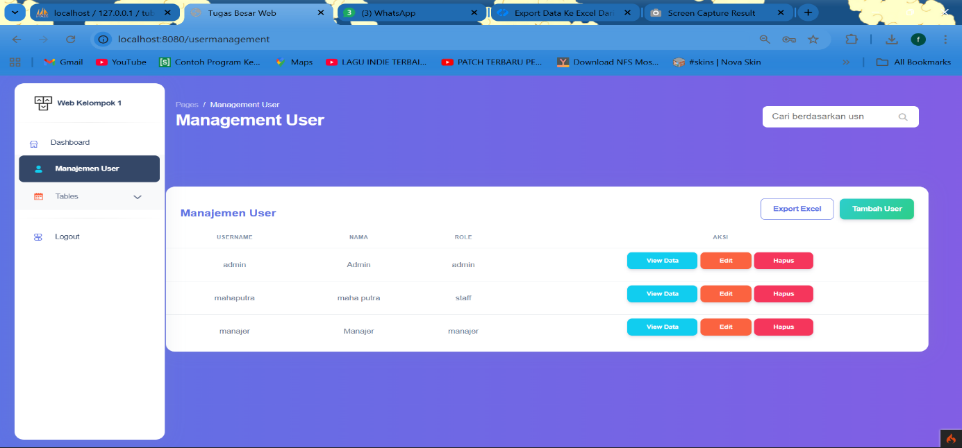

Form tambah user

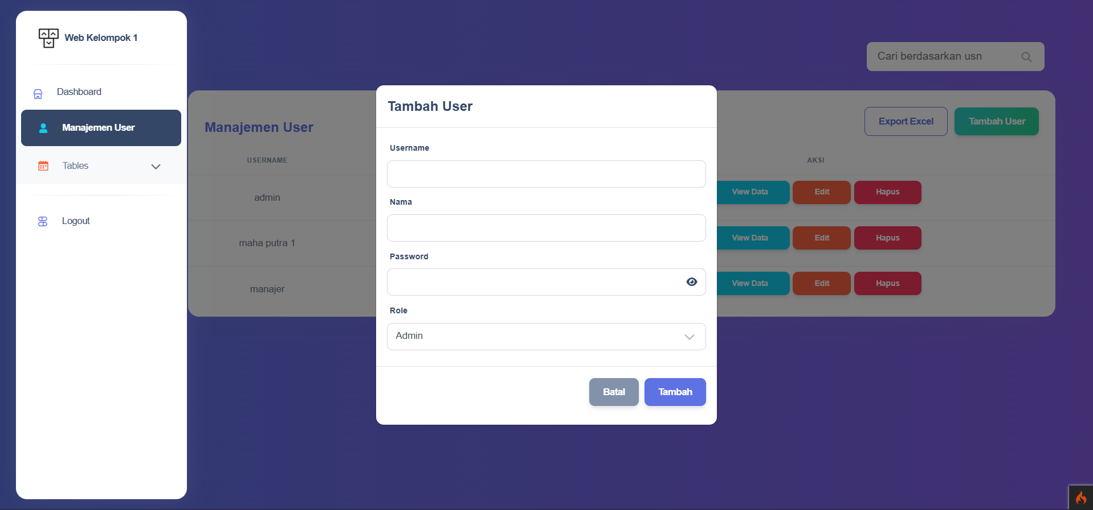

View data user

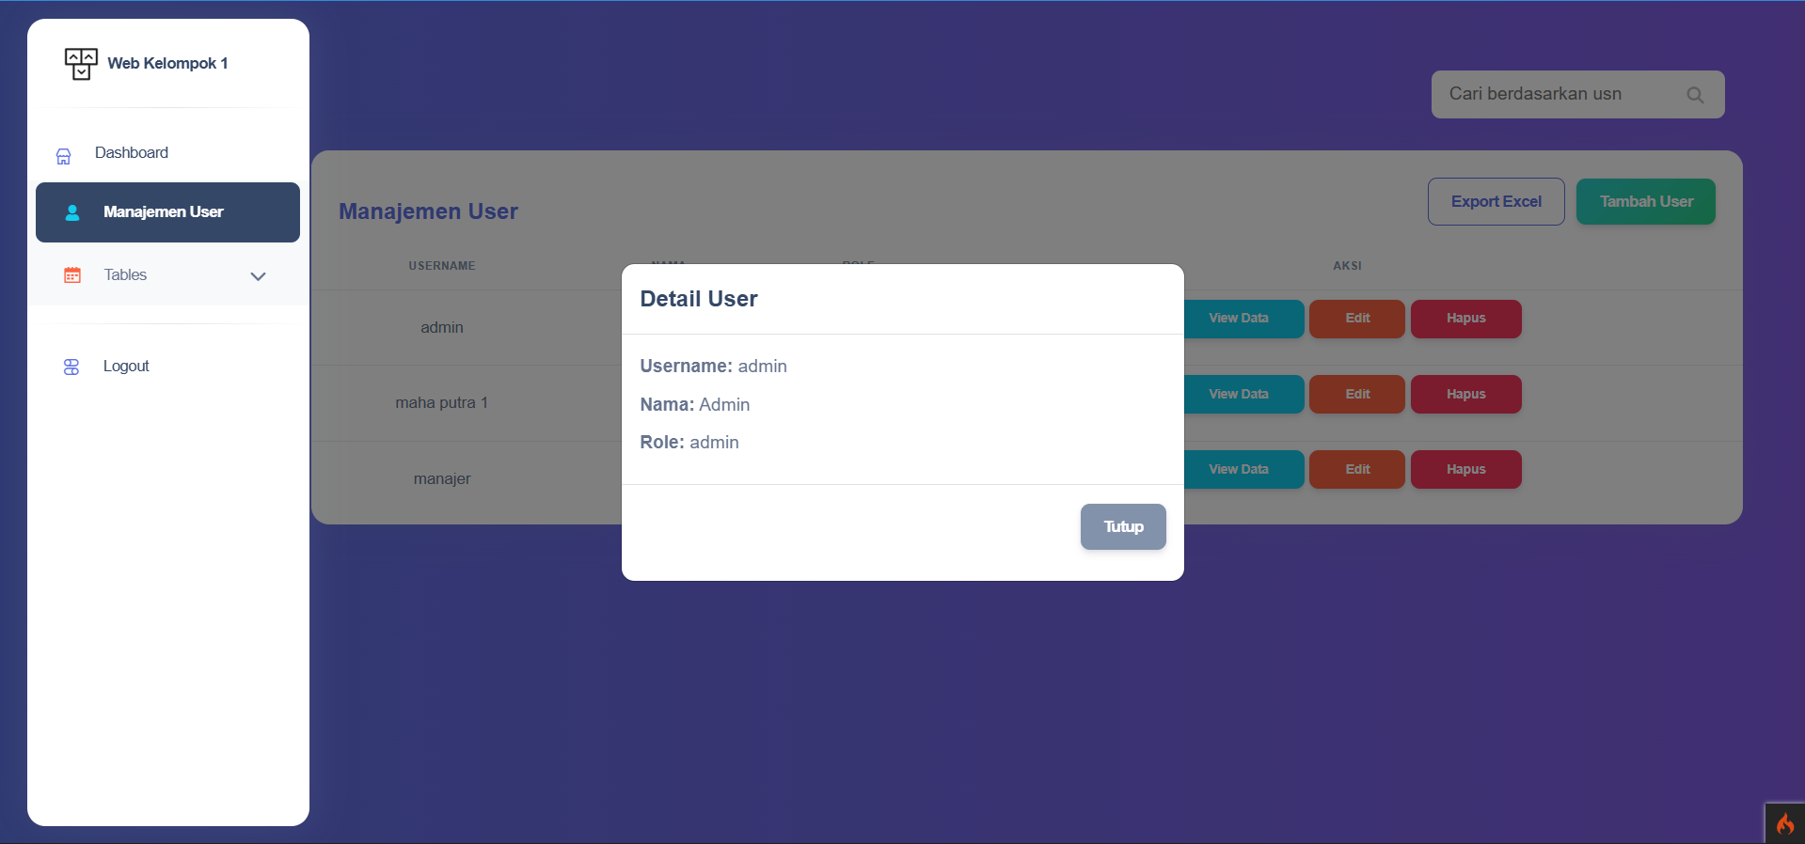

Edit data user

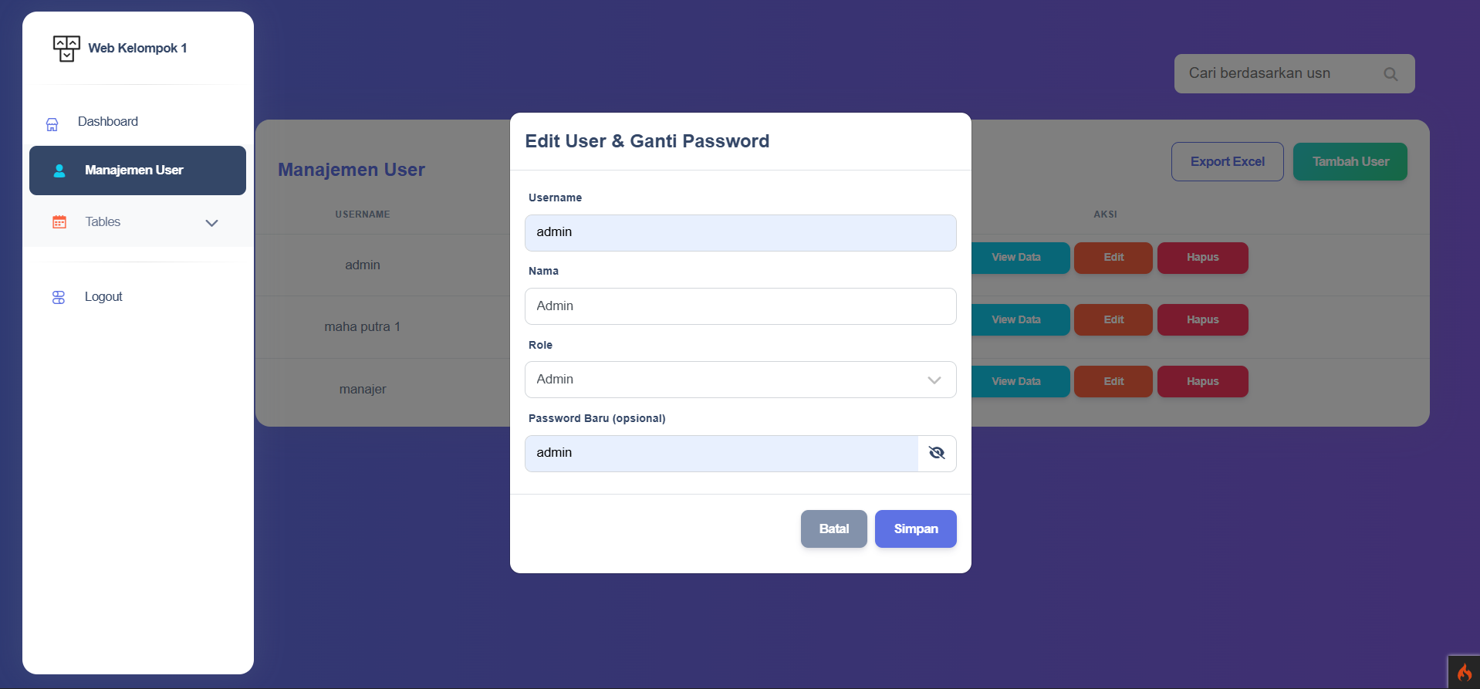

Hapus data user

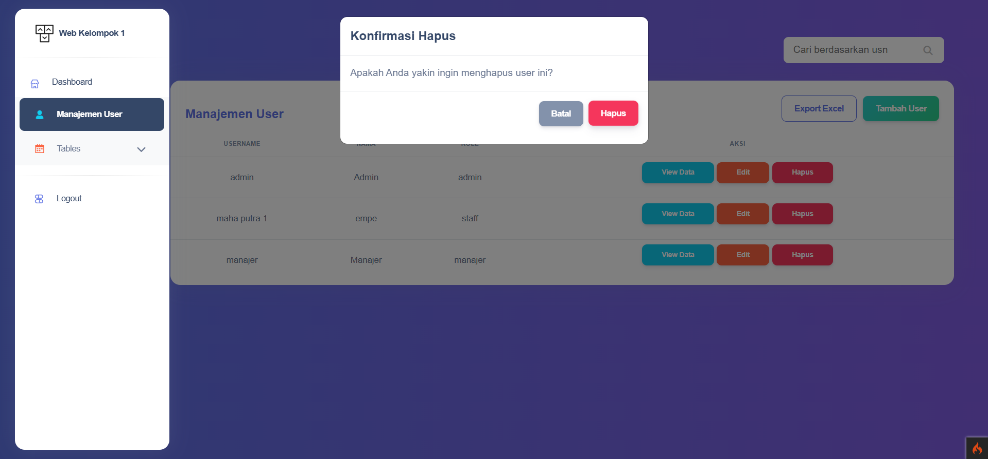

Modal

Update

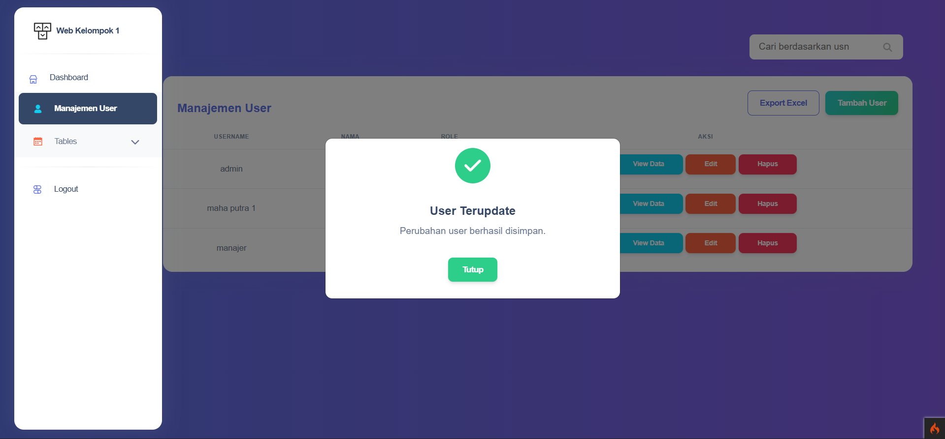

Hapus

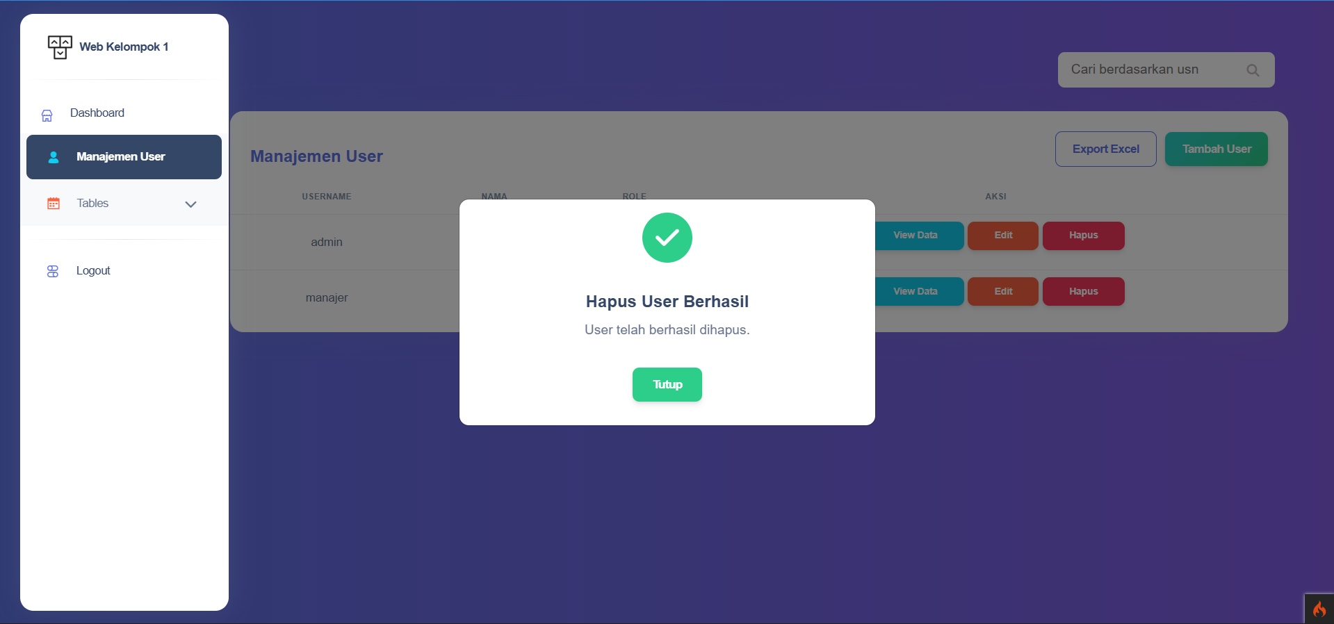

Add user

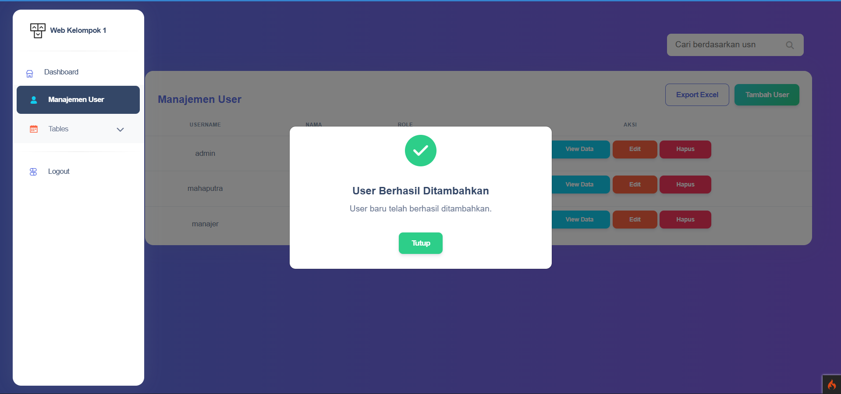

Export Excel manajemen user

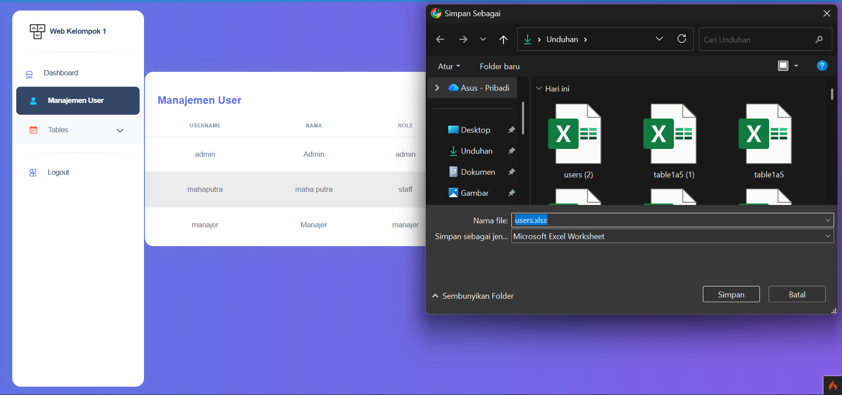

Hasil

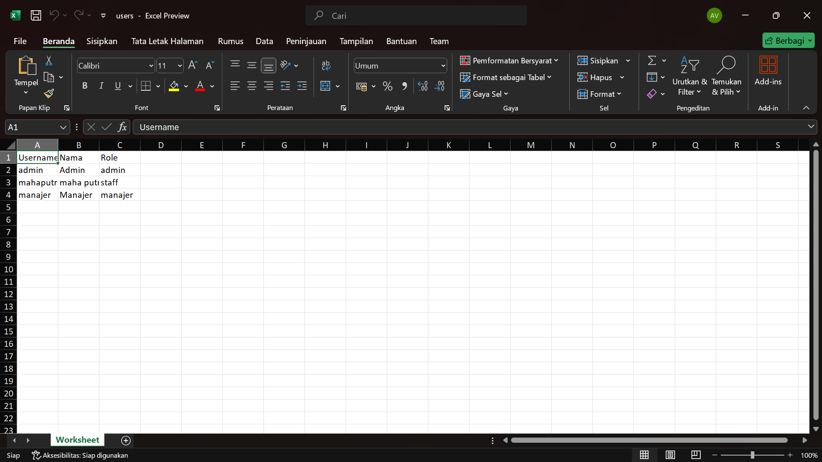

Tampilan tabel 1a1 – 1a5 sama khusus admin ada export dan crud

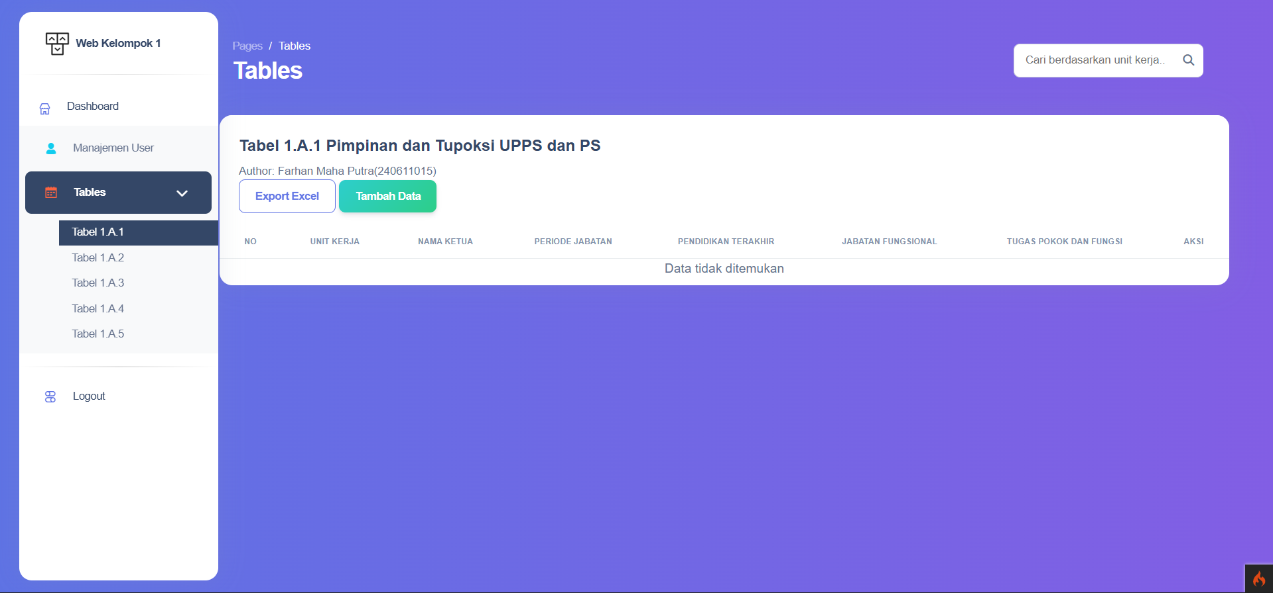

Export excel tabel 1a1 – 1a5 bisa semua dan ini saya screenshoot bagian download nya saja, lalu bagian excel saya screenshoot semua

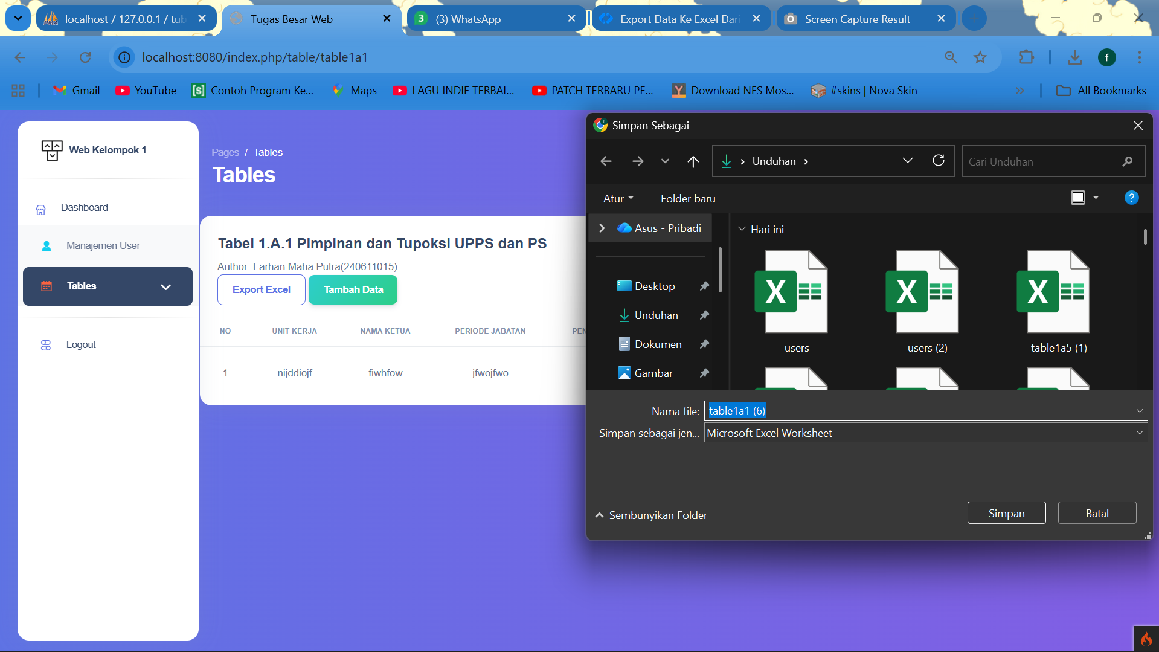

Tabel export excel 1a1

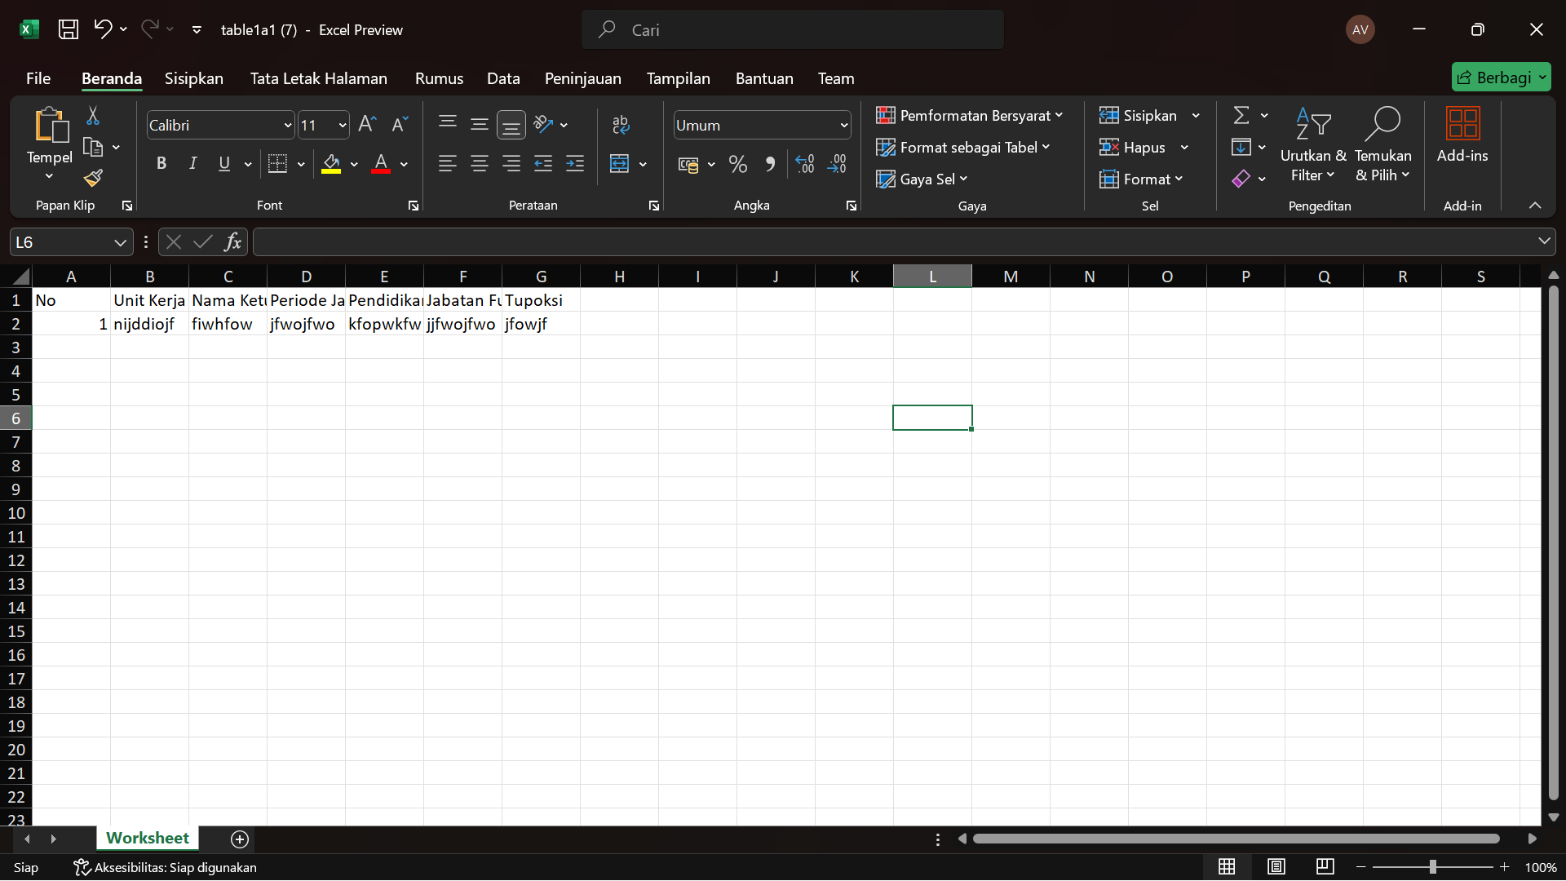

Tabel export excel 1a2

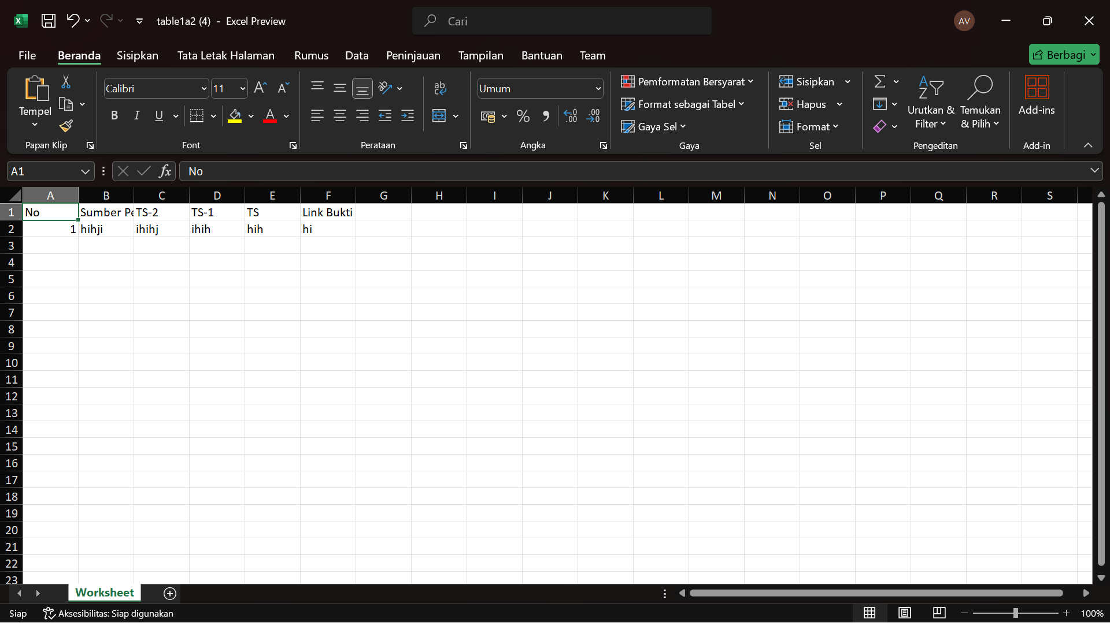

Tabel export excel 1a3

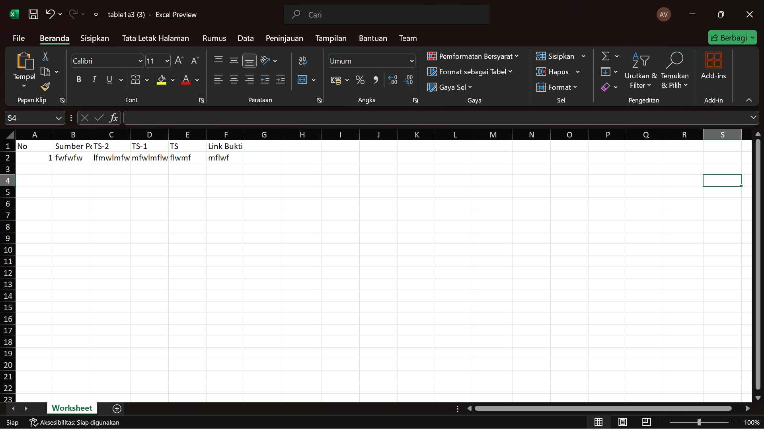

Tabel export excel 1a4

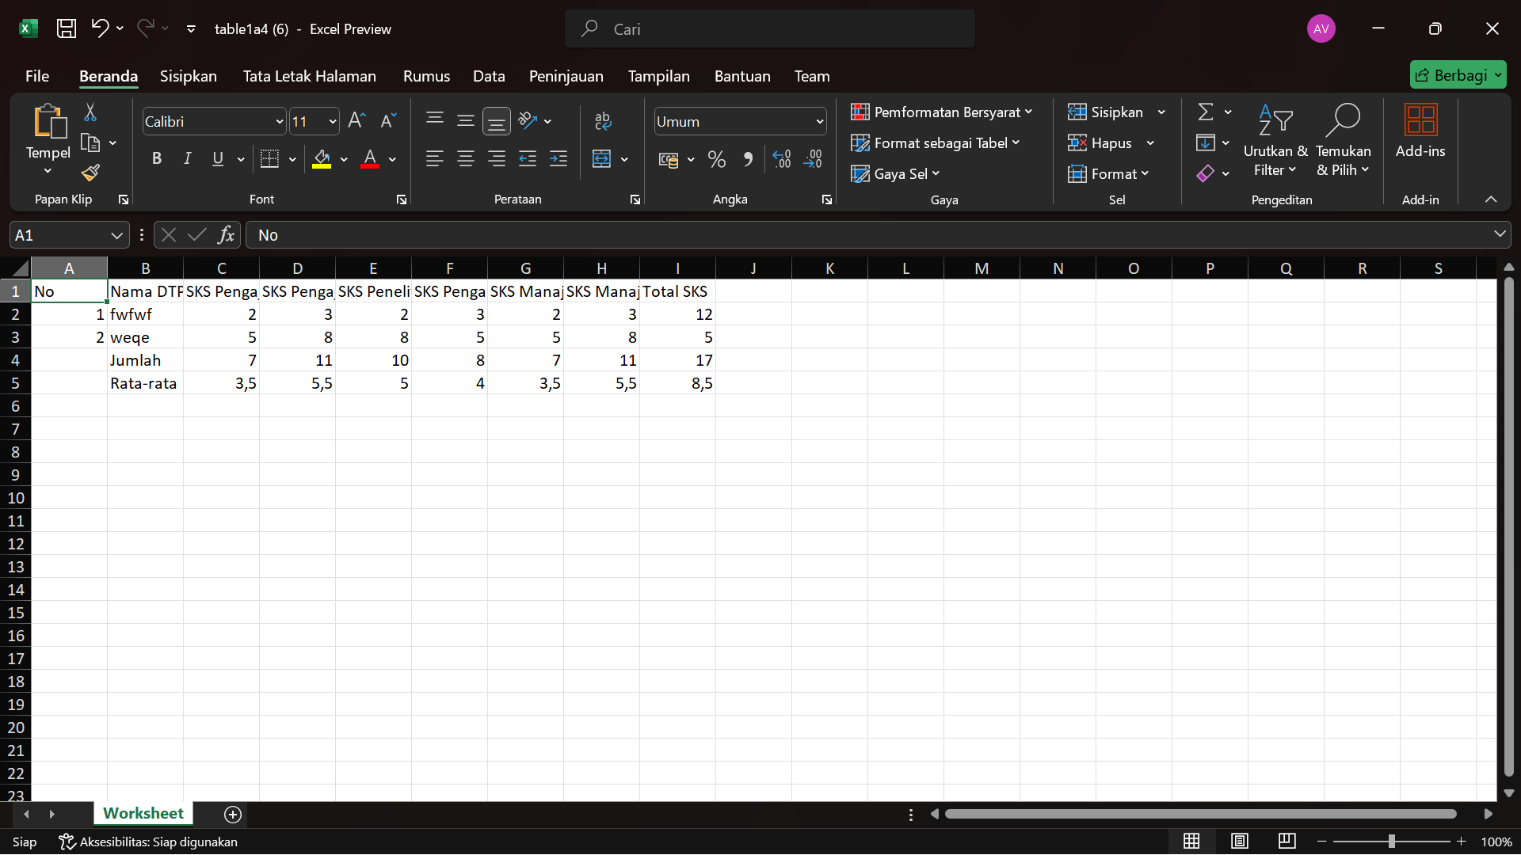

Tabel export excel 1a5

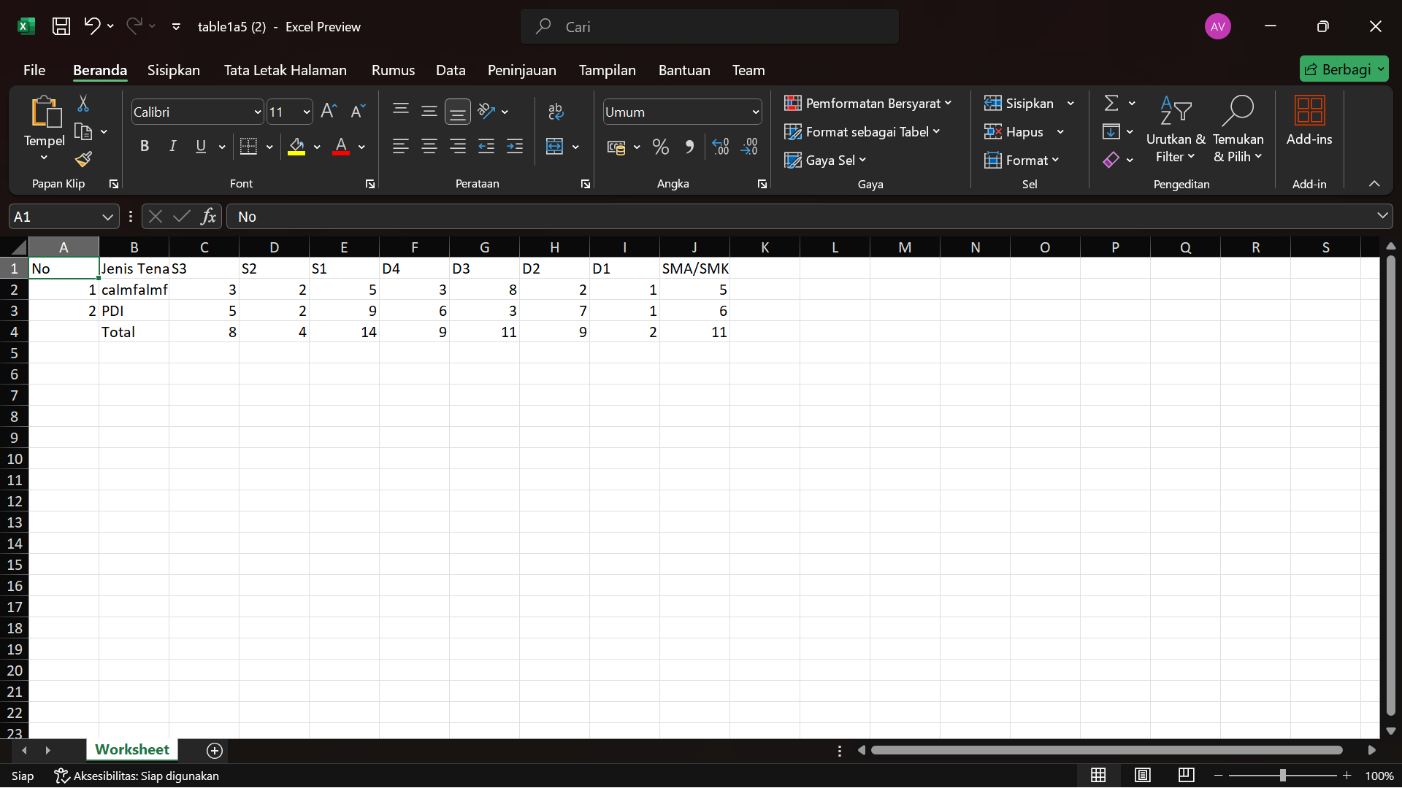

Tampilan dashboard staff hanya bisa lihat dan export excel dan hasil excel nya tetap sama

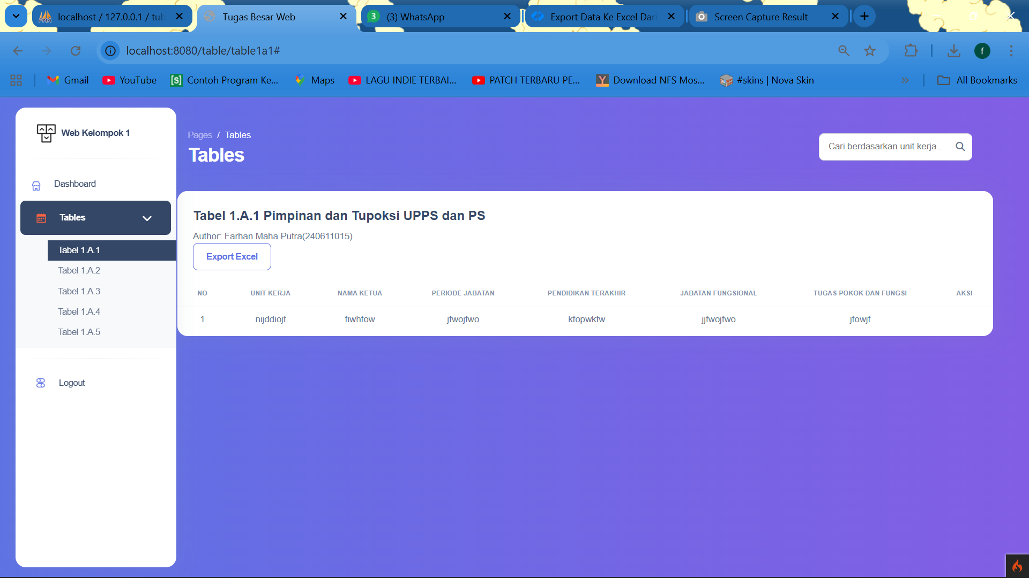

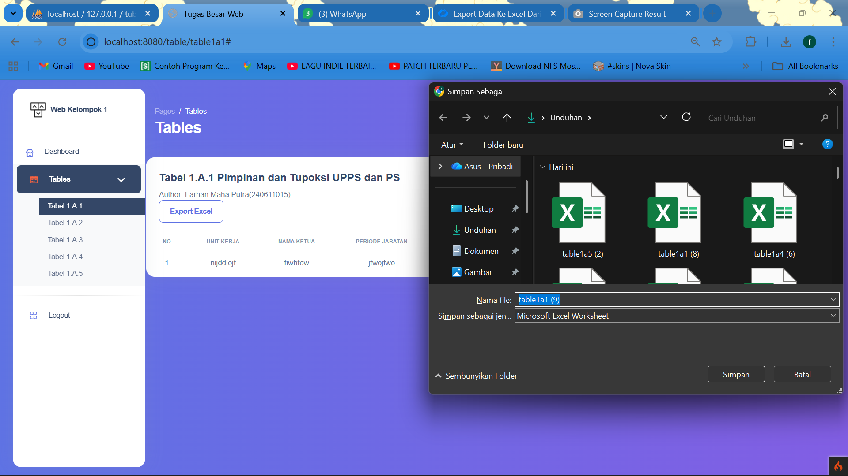

Tampilan dashboard manager bisa crud dan export tapi yidak ada page management user ( download excel, srud bisa semua)

